**6. Implement program to apply moving average smoothing for data preparation and time series forecasting.**

| **EX.N0 : 6** | **Implement program to apply moving average smoothing for data preparation and time series forecasting.** |
| --- | --- |
| **DATE : 05/04/2025** |

**AIM:**

To Implement program to apply moving average smoothing for data preparation and time series forecasting.

**PROGRAM:**

import numpy as np

import pandas as pd

import matplotlib.pyplot as plt

from sklearn.model_selection import train_test_split

from statsmodels.tsa.holtwinters import SimpleExpSmoothing

file_path = r"C:\Users\heman\OneDrive\Desktop\abdul\TSA\EX 5\Crude Oil Prices Daily.xlsx" (1)\FINAL_USO.csv" # Update path

df = pd.read_csv(file_path, parse_dates=["Date"], index_col="Date")

df.columns = df.columns.str.strip()

if "Adj Close" not in df.columns:

print("Error: 'Adj Close' column not found!")

print("Available columns:", df.columns)

exit()

target = "Adj Close"

df["SMA_10"] = df[target].rolling(window=10).mean() # 10-day SMA

df["SMA_20"] = df[target].rolling(window=20).mean() # 20-day SMA

df.dropna(inplace=True) # Remove NaN values from SMA columns

X = df[["SMA_10", "SMA_20"]]

y = df[target]

train_size = int(len(df) * 0.8) # 80% train, 20% test

X_train, X_test = X.iloc[:train_size], X.iloc[train_size:]

y_train, y_test = y.iloc[:train_size], y.iloc[train_size:]

model = SimpleExpSmoothing(y_train).fit(smoothing_level=0.2, optimized=False) forecast = model.forecast(len(y_test)) # Predict the same length as test set

forecast.index = y_test.index

plt.figure(figsize=(12, 5))

plt.plot(y.index, y, label="Actual Price", color="blue", alpha=0.5)

plt.plot(y_test.index, forecast, label="Forecast", color="red", linestyle="dashed") plt.title("Gold Price Forecast using Moving Average & Exponential Smoothing") plt.xlabel("Date")

plt.ylabel("Price")

plt.legend()

plt.show()

**OUTPUT:**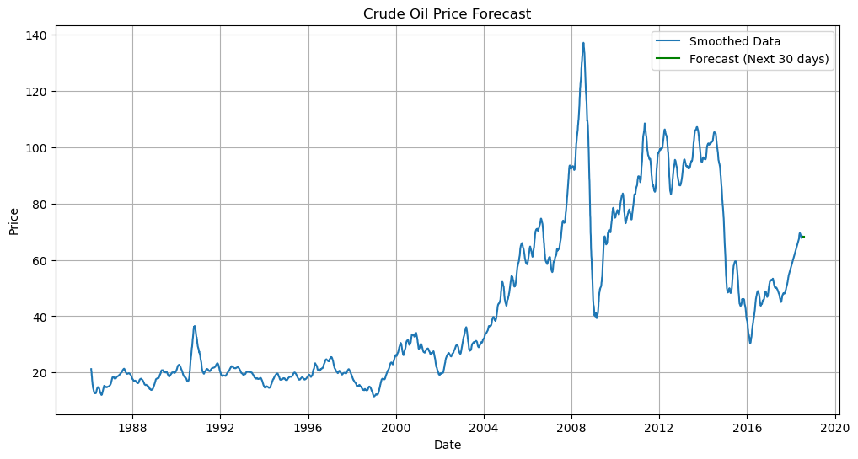

**RESULT:**

Thus, the program for Implement program to apply moving average smoothing for data preparation and time series forecasting is executed successfully.